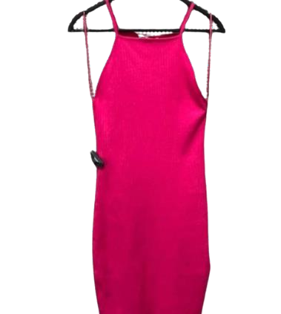

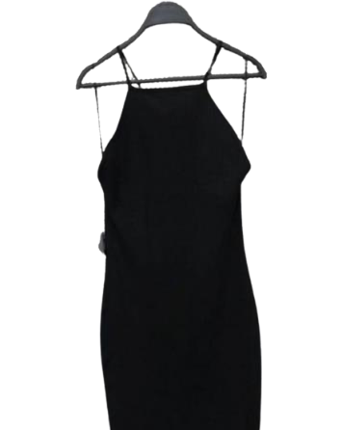 PACKING LIST - ZARA ITEMS

|  |  |  |  |
| --- | --- | --- | --- |
| **COLOUR** | **SIZE** | **QUANTITY** | **TOTAL** |
| **Black** | S | 7 500 | 30 000 |
| M | 7 500 |
| L | 7 500 |
| XL | 7 500 |

|  |  |  |  |
| --- | --- | --- | --- |
| **COLOUR** | **SIZE** | **QUANTITY** | **TOTAL** |
| **FUSHIA** | S | 7 500 | 30 000 |
| M | 7 500 |
| L | 7 500 |
| XL | 7 500 |

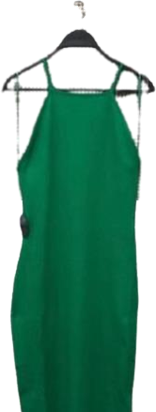

|  |  |  |  |
| --- | --- | --- | --- |
| **COLOUR** | **SIZE** | **QUANTITY** | **TOTAL** |
| **GREEN** | S | 7 500 | 30 000 |
| M | 7 500 |
| L | 7 500 |
| XL | 7 500 |

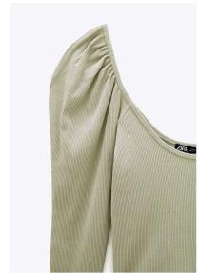

|  |  |  |  |
| --- | --- | --- | --- |
| **COLOUR** | **SIZE** | **QUANTITY** | **TOTAL** |
| **UNIQ** | S | 2 750 | 11 000 |
| M | 2 750 |
| L | 2 750 |
| XL | 2 750 |